

Meeting Minutes

Nursing Undergraduate Society Meeting

13/02/2024

4:30PM

In-Person Meeting

Taken by: Amanda

**Attendance:** Erica Cambly

**2nd Year Members**: Vivian Li, Mariah Brown, Siobhan McAdam, Avery Russell, Michela Baccala, Shraddha Timalsina, Lauren Santangelo, Elizabeth O’Neill, John Cernat, Jessica Zhang, Tiah Di Benedetto, Erica Rudd, Anissa Yu, Julia Zheng, Vian Chan, Data Rajashitaz, Sidra Noorzad, Benji Finestone, Mabel Zheng, Audrey Ing, Sara Santos, Emily Lush

**1st Year Members:** Lauren Mage, Amanda Ombricolo, Emily Xu, Annie Jiang, Sarah Mendez, Farah Garada, Serena Lai, Amanda Ha, Parveen Dhillon, Samantha Rapson, Sydney Dobronyi, Katherine Chen, Tom Joseph, Zoe Simas, Jade Gracey, Paula Rasiulis, Ana Constantin, Celine Frederick, Ria Patel, Olena Zubrytska, Amna Zafar

**Regrets:**

1. **Opening Remarks**
2. **Approval of Agenda**

Motion: Shraddha Timaalsina Seconder: Lauren Santangelo Passed: yes!

1. **Approval of the Previous Minutes**

Motion: Avery Russell Seconder: Benji Finestone Passed: yes!

1. **Report from the Executives**
   * President ----------------------------------------------------------------------------------------------Vivian Li
     + Meeting for Career Fair with GNSS in June - Let me know if there’s any organizations you want to see!
     + NUS elections in March for 2024-2025 team
       - President (1)
       - Senior Social Coordinators (2)
       - Senior Equity Coordinators (2)
       - Senior Wellness Coordinator (1)
       - Senior Publication Coordinators (2)
       - Mentorship Coordinators (2)
       - Second Year Representative (1)
       - Senior Global Health Representatives (2)
       - Senior Athletics and Recreation Representative (1)
   * Vice-President --------------------------------------------------------------------------------Lauren Mage
     + Applications for the Student Opportunity Fund open tomorrow for ~2 weeks.
     + Second Blood Drive planning underway with GNSS for the middle of March
   * Finance------------------------------------------------------------Mariah Brown & Siobhan McAdam, Emily Xu & Annie Jiang
     + Reimbursements/invoices that have been emailed to us are currently in the works

* + Communications------------------------------------------------Avery Russell & Amanda Ombricolo
    - No updates :)

1. **Report of Committees**
   * Equity Coordinators----------------------------------------------------- Michela Baccala & Shraddha Timalsina, Sydney Dobronyi & Katherine Chen
     + GNSS x NUS event on the 29th.
       - This year’s theme for BHM is Black Excellence.
       - The event will be a panel discussion about the mental fatigue from experiencing racism and stereotypes.
   * RNAO Delegates----------------------------------------------Lauren Santangelo & Ana Constantin
     + Thank you to those who filled out our RNAO interest group survey
     + In-person event in March after class, in the nursing lounge (March 18th?)
       - Goal is to bring representatives from 4 different RNAO interest groups
       - Incentive to attend: it’s free networking and snacks! (numbers for first and second year classes–need to give a quote for snacks to RNAO)
     + Webinar for New Grads *(geared towards second year class)* - RN careers, mentorship, professional liability protection
     + Automatic enrollment of student emails since fee already included in tuition–is this possible? → Prof. Cambly to help
   * CNSA Delegate--------------------------------------------------------Elizabeth O’Neill & Amna Zafar
     + CNSA National Conference in Edmonton debrief
       - Position statements passed
       - Plans for information dissemination and suggestions
         * What is CNSA
         * Presenters and connections (CNA, GTA delegates, ONA, CINA)
       - Next year in Halifax, hosted by Dalhousie
       - Reimbursements
     + Potential CNSA Regional (ON) Conference for next year
       - Alternative collaborative event with York for nursing speed dating
     + Coffee with ONA event
       - Scholarship opportunities
   * IPE Representative---------------------------------------------------John Cernat & Olena Zubrytska
     + 1st years: Last mandatory IPE event of the year (Safe Medication Practices) was a success, thank you nursing students for participating! More information about elective events will continue to be shared as it becomes available.
     + 2nd years: we are no longer required to attend the palliative care IPE session on February 26th…instead we must attend one (1) elective IPE event.
       - Please register for an elective IPE event sooner rather than later (limited availability after April)
       - If you have previously completed an elective IPE event, this counts, no need to register
     + Pain week: March 4, 5, 6 ALL MANDATORY
       - March 4th and 6th are virtual
       - March 5th is in person
       - Please look out for emails from myself and CACHE closer to the date
       - Clinical for wednesday will try to be rescheduled during this week
   * IHI Delegate----------------------------------------------------------------------------------Jessica Zhang & Celine Frederick
     + No updates!
   * UTSU Representative-----------------------------------------------------------------Tiah Di Benedetto & Ria Patel
     + UTSU approved NUS for our membership - found out grant exists - finance is applying for the grant, membership and grant application will be added to the constitution so everyone is aware for the following years that UTSU and Finance to collaborate on the application. NUS just needs to decide where these funds can be allocated ($500 for now and $6,000 in the coming years).
       - Tentatively → Social to use funds for formal

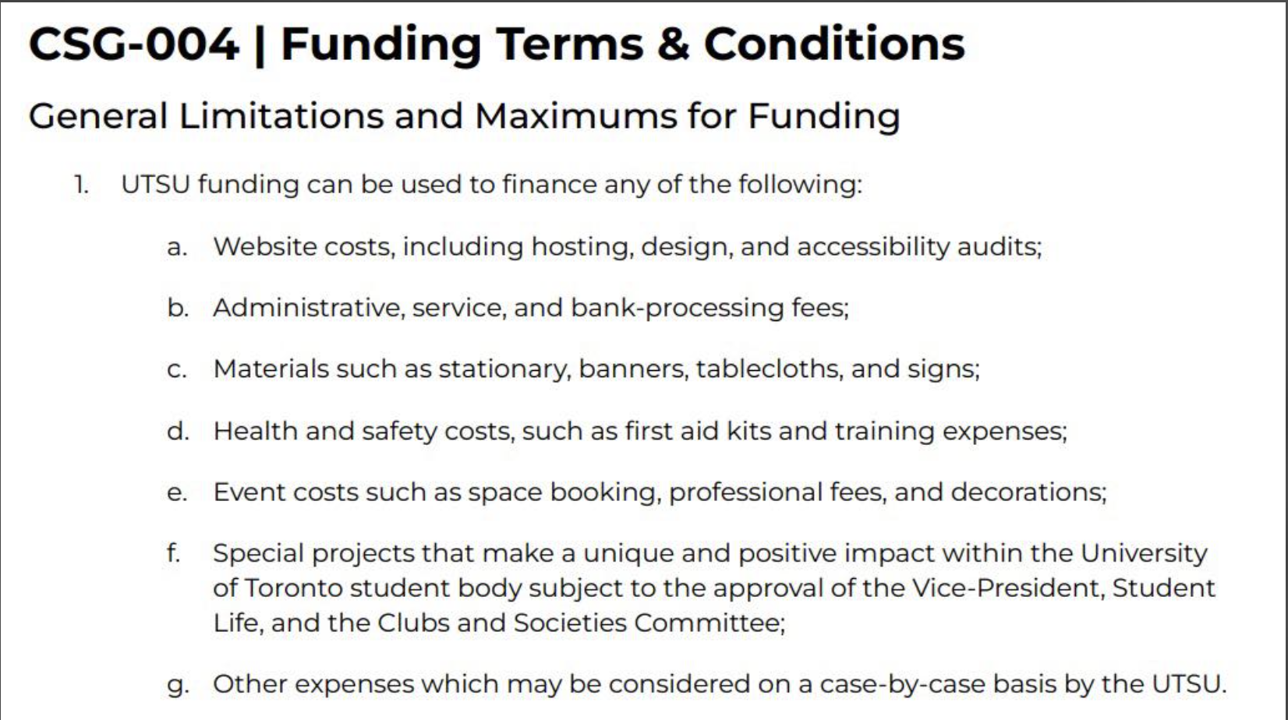

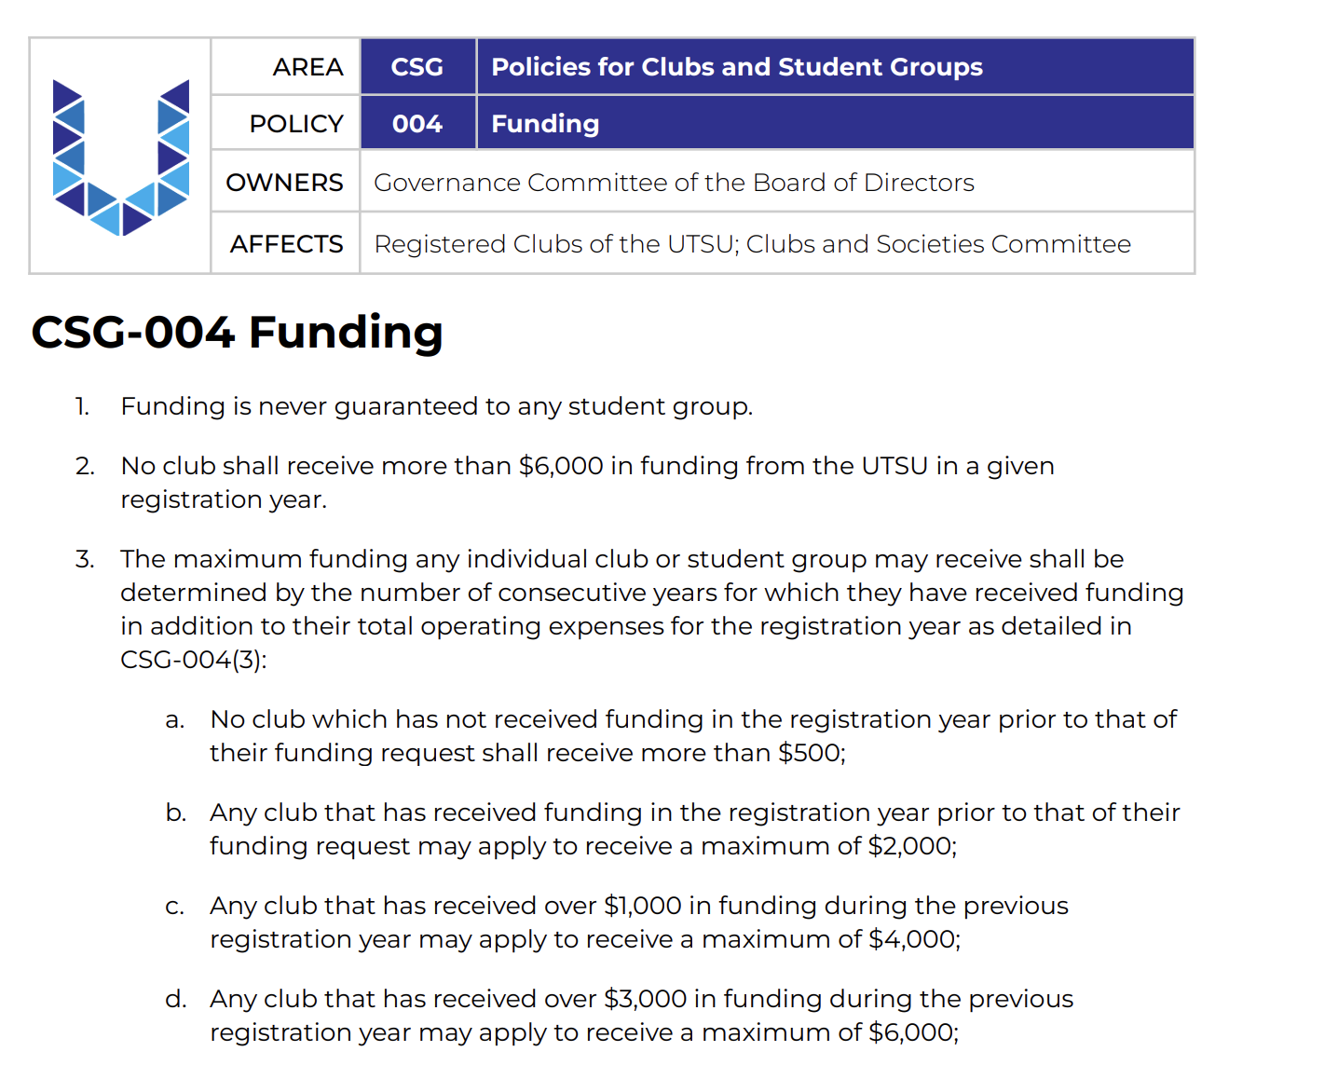

* + - Results from the gym membership extension showed most students prefer the month-to-month option. This information will be used by UTSU to help inform their decision, and updates to come.
    - The Uber ride-share will not be returning this semester, funds will be allocated to the student bursaries, still open until February 25th.
      * We were told the issues with the ride-share would be addressed next year if they try the contracts again.
    - If anyone is having issues with UTSU not getting back to them or not answering their questions please CC Tiah or Ria in your emails or reach out!
  + Social Coordinators----------------------------------------------------------- Erica Rudd & Anissa Yu, Sarah Mendez & Farah Garada
    - Hart house got back to us and the grad gala estimated date we have on hold until February 26th is **June 28th, 2024 (tentative)**
    - Estimated cost for approximately 200 people is $21,073 (venue, meal, set-up fee)
    - Creating subcommittee to look into other venues and help with the search
  + Year Representative----------------------------------------------------------------------------Julia Zheng & Paula Rasiulis
    - Graduation jackets now available for preorder (patagonia)
    - Deadline: February 15th, 2024
    - Available in 3 colours, please make sure to pay on square and by the deadline otherwise your order is invalid
    - Bookstore graduation jackets coming soon!
      * Name embroidery on the sleeve or on the front of the jacket?
    - Looking to see how much name embroidery would be for winter merch
      * PASTEL PINK
    - Longer sleeve options for scrub tops for clinical or having a jacket/sweater option that is faculty approved
  + Athletic and Recreation Representatives---------------------------------------------------Vian Chan & Jade Gracey
    - Cancellation of CN Tower Climb Event
      * There is a $25 registration fee and a $125 fundraising fee PER PERSON
    - Nursing Games Interest Form
    - Volleyball and badminton interest
  + Publications Coordinators-------------------------------------------- Sidra Noorzad & Amanda Ha, Parveen Dhillon, Samantha Rapson
    - Nursing brands that CU Advertising could contact on our behalf to add to our yearbook (think brands like Mobb Scrubs, local hospitals, etc.)
    - Thoughts on creating a “survival guide” for incoming students? Would include advertisements and *could* be sold to first years as a PDF (or included in orientation fees????)
      * If so -> maybe creating a document with advice we could give
  + Global Health Representatives —-------------------------------Benji Finestone & Mabel Zheng, Tom Joseph & Zoe Simas
    - No updates
  + Wellness Coordinators------------------------------------------------------------------------- Audrey Ing & Serena Lai
    - Start date for Clinical Support Group TBD
    - Warm and Fuzzies will be emailed starting on February 14, 2024 but will still accept form responses until February 15, 2024 @ 11:59 pm
      * Over 100 responses so far!
  + Mentorship Coordinator--------------------------------------------------- Sara Santos & Emily Lush
    - Working with GNSS on hosting a Masters of Nursing Student Panel event! (potentially in March)
      * Hoping to have other health related masters programs (ex. Dana Lana School of Public Health) as per requests from students

1. **Other Business/Discussions**--------------------------------------------------------------------------------- NUS
   * Transition meetings for new electives ASAP
2. **Update from Faculty**---------------------------------------------------------------------------------- Erica Cambly
   * TMU & UofT collab for people who work clinically → Sigma
     + Invite to join if in top 1/3 of class and senior students and is an honour that you can wear during grad ceremony

**Next Meeting: February 6, 2024**